
Lesson 7: On the Move
Scratch
VIDEO GAME CREATION
This week: enemies stop standing still. Your job is to make every enemy advance slowly toward the player, and clean up any that reach the bottom of the screen without being shot.
Open your own [YourName]Game project from Lesson 6 - don't start a new one.
Tip: no new assets this week - this is a logic-only lesson.

Setup
- Open your [YourName]Game project from Lesson 6.

Level 1 - Minimal (MVP)
Every enemy moves slowly downward, toward the player, instead of sitting still. An enemy that reaches the bottom of the screen unshot is removed - and does NOT count toward your win condition, since it escaped rather than being defeated.
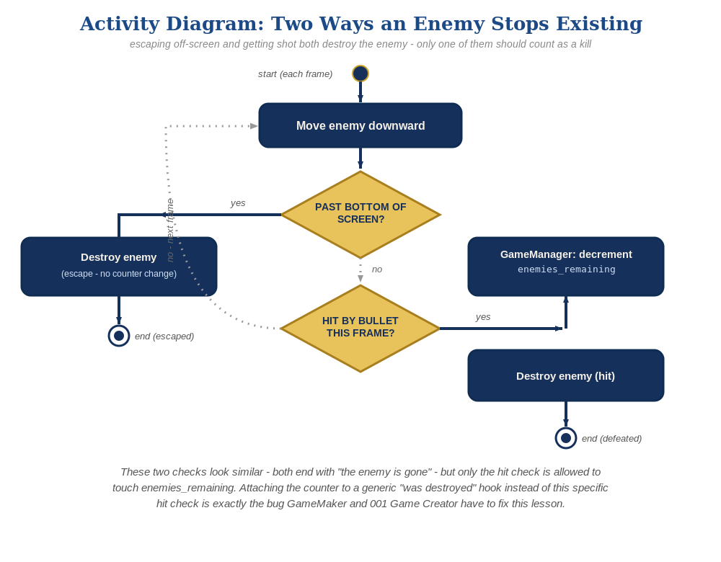
The general escape-vs-hit distinction behind this week's exercise - the same shape in every engine, whatever the exact code or blocks look like.
- On the Enemy sprite's "when I start as a clone" script, inside the forever loop, add "change y by -1" (Scratch's y-axis increases upward, so decreasing y moves an enemy down) - add this as the very first thing inside the loop, before the existing touching check.
- Still inside the forever loop, after the existing touching-check branch, add a second check: "if <y position < -170> then delete this clone" - this removes an enemy that escapes off the bottom, with no broadcast and no effect on enemies_remaining.
- Click the stage and let the enemies drift downward to test - shooting one should still work exactly as before, and letting one reach the bottom unshot should just make it vanish, with no "You Win!" message.

Level 2 - Complete (Alpha/Beta)
A moving enemy can still be shot and destroyed correctly, and an enemy that escapes off the bottom never triggers "You Win!" by accident.
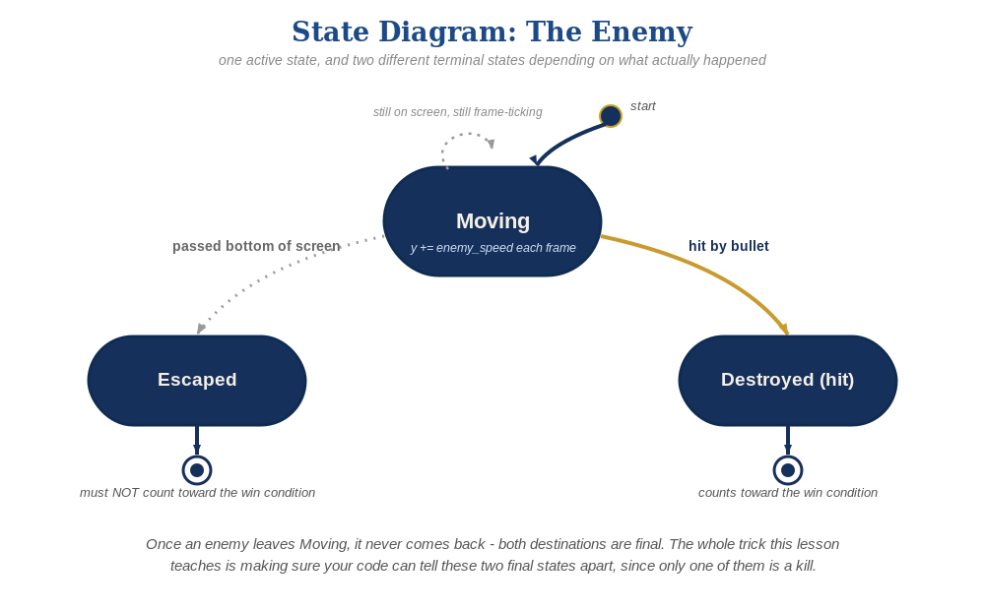
The enemy's two possible endings this week - only one of them should count as a kill.
- Shoot a moving enemy to confirm collision still works correctly while it's in motion.
- Let at least one enemy escape off the bottom unshot, and confirm "You Win!" does NOT appear - only enemies_remaining, only ever changed inside GameManager's "when I receive [enemy hit]" script, controls that message. The Enemy's touching-Bullet branch broadcasts enemy hit but never touches enemies_remaining itself.

Level 3 - Refined (Ready to Publish) - pick any that interest you
- Visual: give each enemy a slightly different downward speed based on enemy_number (its position in the row) at spawn time, so they don't all move in a perfectly straight line together.
- Structure: keep the two checks inside the forever loop clearly separate - one only ever runs on "touched by a bullet" (and only ever broadcasts enemy hit), the other only ever runs on "reached the bottom" (and never broadcasts anything). Never let one branch do both jobs.

If Something's Wrong
- Enemies don't move at all: confirm "change y by -1" is actually inside the forever loop, not outside it or in a script that only runs once.
- "You Win!" appears even when enemies escaped unshot: confirm the escape-cleanup branch never broadcasts enemy hit - only the touching-Bullet branch may do that, and only GameManager's script ever changes enemies_remaining.
- Enemies move but never disappear at the bottom: confirm the y position < -170 check is inside the same forever loop, using the correct comparison direction (less than, not greater than).

Want More?
Student Resource List > Scratch section, or scratch.mit.edu/ideas

